Current Project Information

Hospitality

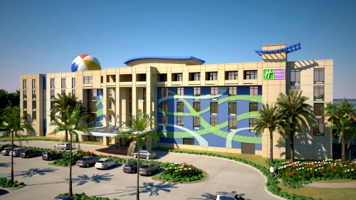
Emerald Breeze Holiday Inn Resort
General Contractor: dck Worldwide

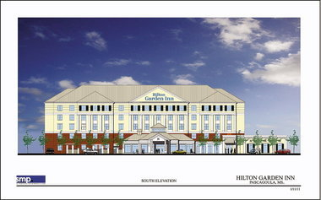
Hilton Garden Inn Pascagoula
General Contractor: Case Construction

Healthcare


SHH Heart & Vascular Power VAV’s
General Contractor: Gulf States Automation

Central Energy Plant Emergency Generator
General Contractor: Sanders Brothers Electric, Inc.

The Haven Physical Therapy
General Contractor: Total Construction Company

Sacred Heart Hospital Generator Bldg.
General Contractor: Mickelson Construction Services, Inc.

Sacred Heart Emergency Generator Installation
General Contractor: Sanders Brothers Electric, Inc.

Pediatric Associates Addition
General Contractor: Total Construction Company

Medical Center Clinic
General Contractor: Air Design Systems, Inc.

Commercial

Perdido Fire Station
General Contractor: Rod Cooke Construction, Inc.

Gulfquest
General Contractor: Johnson Controls, Inc.

Coastal Bank & Trust 2nd & 4th Floor Renovations
General Contractor: Wescon Corporation

Veterinary Emergency & Referral
General Contractor: Hewes & Company, LLC

Juvenile Justice
General Contractor: Johnson Controls, Inc.
Military


NAS Building 416
General Contractor: Engineered Cooling Services, Inc.

Corry Water Treatment
General Contractor: Oneida total Integrated Ent.

NAS Child Care Control
General Contractor: Engineered Cooling Services, Inc.

NAAS 3450 Chiller Replacement
General Contractor: Engineered Cooling Services, Inc.

Corry Buildings 3702 & 3705
General Contractor: Siemens Industry, Inc.

Corry 511 Chiller & VFD
General Contractor: Engineered Cooling Services, Inc.

