Recent / Past Projects

Hospitality

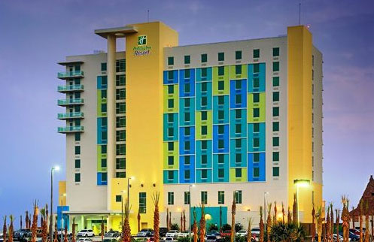
Holiday Inn Resort, Pensacola Beach, FL.
General Contractor: Robins & Morton Group

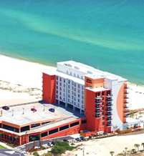
Hampton Inn, Orange Beach, AL.
General Contractor: Robins & Morton Group

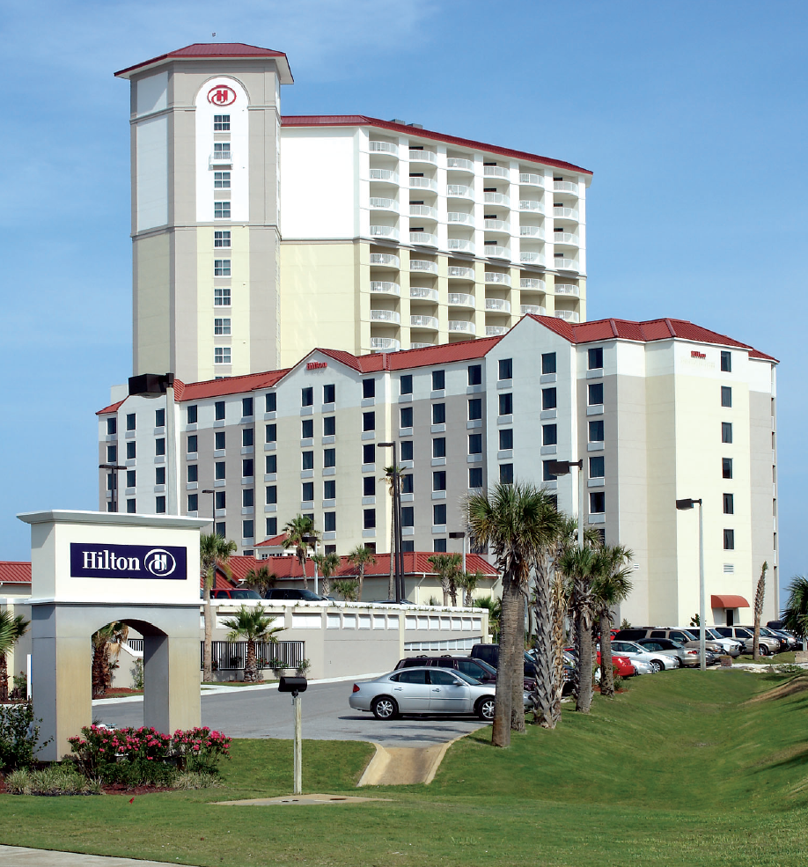
Hilton Garden Inn, Pensacola Beach, FL.
(17) Story Tower/Condominium Hotel Addition
General Contractor: McCrory Building Company, Inc.

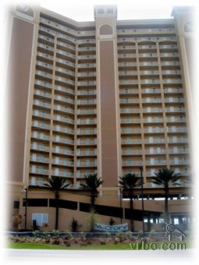
Seawinds Condominiums, Orange Beach, AL.
One (20) Twenty Story Condominium with (6) six story amenities building
General Contractor: McCrory Building Company

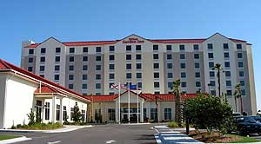
Hilton Garden Inn, Pensacola Beach, FL.
Complete electrical installation of new 7-Story Hilton Hotel & Meeting Facility
General Contractor: Greenhut Construction Co., Inc.

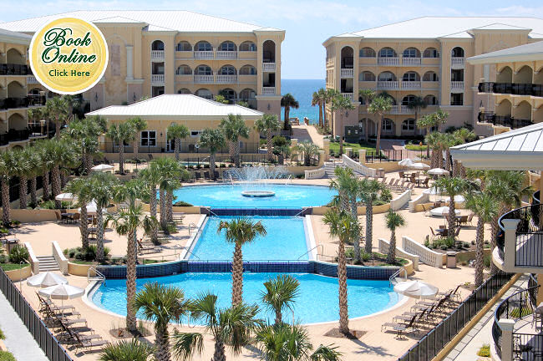
Adagio Condominiums, Santa Rosa Beach, FL.
Multi- Building Condominiums with Amenities Building
General Contractor: Brasfield & Gorrie, LLC

View Point Condominiums, Navarre, FL.
General Contractor: McCrory Building Co., Inc.

INN at Summerwind Phase I, II & III, Navarre Beach, FL
General Contractor: Greenhut Construction Co., Inc

Healthcare

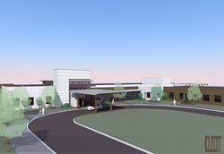
Sacred Heart Hospital on The Gulf, Port St. Joe, FL.
General Contractor: Greenhut Construction Company, Inc.

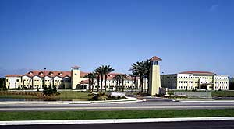
Sacred Heart Hospital on the Emerald Coast
New Birthing Center at Sacred Heart Hospital on the Emerald Coast
General Contractor: Greenhut Construction Company, Inc.

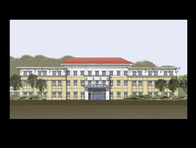
Sacred Heart MOB Gulf Shores, AL.
Pinnacle MOB – Family Practice
Pinnacle MOB –Rehabilitation
Pinnacle MOB – Timeshare
Pinnacle MOB - MRI
General Contractor: Brassfield & Gorrie LLC

SHH Renovations to Radiology Office
General Contractor: Mickelson Construction Services, Inc.

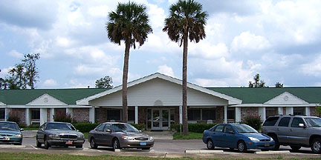
Santa Rosa Health & Rehabilitation Center
General Contractor: Mickelson Construction Services, Inc.

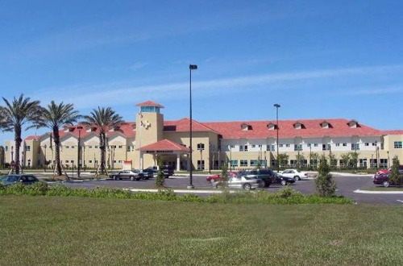
Siemens Somatom Sensation 64 CT – SHH on the Emerald Coast, Miramar Beach, FL
General Contractor: Greenhut Construction Company, Inc.
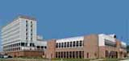
Controls Navy Hospital, Pensacola, FL.
General Contractor: Siemens Building Technologies, Inc.

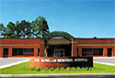
D. W. McMillan Memorial Hospital – Elevator Addition, Brewton, AL.
General Contractor: Mickelson Construction Services, Inc.


Sacred Heart Hospital, Pensacola, FL.
Renovations & Alterations Outpatient Surgery
General Contractor: Mickelson Construction Services, Inc.

Sacred Heart Hospital, Pensacola, FL.
Campus wide lighting; exterior and landscaping upgrade
General Contractor: Sanders Brothers Electric, Inc.

Ped’s Relocation
General Contractor: Total Construction Co.

Sacred Heart Hospital Energy Plant
SHH Energy Plant
General Contractor: Mickelson Construction Services, Inc.

Sacred Heart Hospital, Pensacola, FL.
Design Build; Change out Emergency Generator System

Sacred Heart Hospital, Pensacola, FL.
New Energy and Chiller Plant with Emergency Generator
General Contractor: Mickelson Construction Services, Inc.

Sacred Heart Hospital, Pensacola, FL.
Internal Medicine
General Contractor: Total Construction

Sacred Heart Hospital, Pensacola, FL.
4th Floor East
General Contractor: Mickelson Construction

Addition and Renovations of Goldenberg Hospice, Covenant Hospice, Inc.
General Contractor: Wescon Corporation

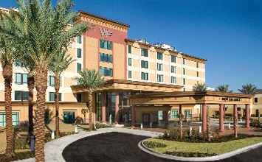
West Florida Hospital
West Florida Hospital – Lobby Renovation’s
General Contractor: Mickelson Construction Services, Inc.

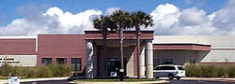
Baptist Medical Park, Navarre, FL
Baptist Medical Park – MOB
General Contractor: Mickelson Construction Services, Inc.

9 Bed NICU Expansion – Sacred Heart Hospital
General Contractor: Greenhut Construction Co., Inc

Sacred Heart Hospital Cardiology
General Contractor: Mickelson Construction Services, Inc.

Sacred Heart Hospital - Women's Diagnostic Center, Destin, FL.
General Contractor: Greenhut Construction Co., Inc

Escambia County Health Department
Bay Design Associates

Renal Care Facility
General Contractor: Mickelson Construction Services, Inc.

Our Lady of Assumption
General Contractor: Greenhut Construction Co., Inc

Sacred Heart – Ann Boroco Center
General Contractor: Total Construction Company

SHH LDR Renovations
Sacred Heart Hospital – LDR Renovations
General Contractor: Mickelson Construction Services, Inc.

SHH NICU Infill
Sacred Heart Hospital – NICU Courtyard Infill
General Contractor: Mickelson Construction Services, Inc.
SHH – ATS Replacement
General Contractor: Sanders Brothers Electric, Inc.

SHH Elevator to EM
General Contractor: Mickelson Construction Services, Inc.

SHH Transformer / Switch Replacement
General Contractor: Sanders Brothers Electric, Inc.

Education

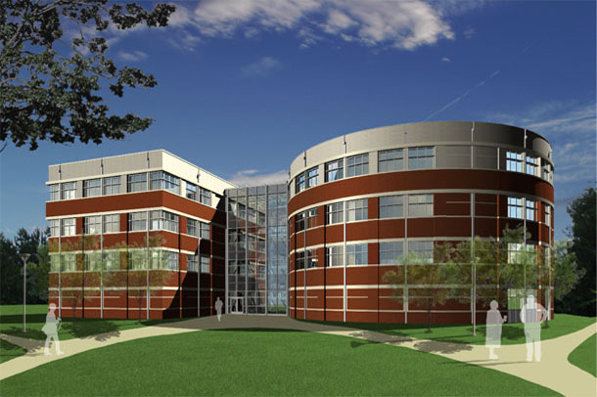
University of West Florida Science & Engineering Building
General Contractor: Greenhut Construction Company, Inc.

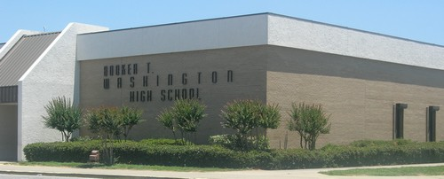
Booker T Washington High School
General Contractor: Greenhut Construction Company

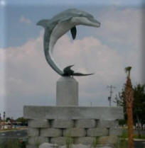
Gulf Breeze High School Fire Alarm Replacement
General Contractor: Ivanco

Gulf Breeze Middle School Fire Alarm Replacement
General Contractor: Ivanco

University of West Florida Bldg. 54 & 73 Renovations
General Contractor: A. E. New, Jr., Inc.

Santa Rosa County School System – Standby Generator Installation
Schmidt Dell Associates, Inc.

Pea Ridge Elementary – Fire Alarm Replacement
General Contractor: Ivanco, Inc.

Ferrypass Middle School
General Contractor: Larry Hall Construction

McArthur Elementary School
General Contractor: Larry Hall Construction

Commercial

Covenant Hospice Interior Renovations Floors 1,2,3
General Contractor: Wescon Corporation

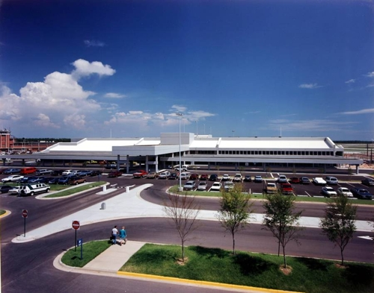
Pensacola Regional Airport - Rental Car Facility
General Contractor: Greenhut Construction


Saenger Theatre Renovations & Additions
General Contractor: Dooleymack Constructors, LLC


UPS Facility Alterations & Additions
General Contractor: ThomCo Enterprises, Inc.

Pensacola Regional Airport - Apron Lighting
Contract with City of Pensacola

Pensacola Regional Airport – Jetway
General Contractor: JetBridge Technology, Inc.


United Bank, Milton, FL.
General Contractor: Total Construction Company

Con – Way Freight, Pensacola, FL.
General Contractor: Total Construction Co.

Juvenile Justice Center
General Contractor: Larry Hall Construction, Inc.

Navy Federal – Parking Lot
General Contractor: Greenhut Construction Co., Inc

Escambia County Sheriff’s Office Renovations
General Contractor: Jack Moore Construction Company

Saltmarsh Cleveland & Gund – Renovations
General Contractor: Biggs Green Construction Co.

Southtrust Bank
General Contractor: Benchmark Construction Co.

Southtrust Bank – Light Poles
General Contractor: Alcon & Associates, Inc

Port of Pensacola
General Contractor: GW Systems

Alvins Island, Pensacola Beach, FL.
General Contractor: Benchmark Construction Co.

Lillians Restaurant, Perdido Key, FL
General Contractor: U.S. General Construction, Inc.

PCC Rawson Nursery
General Contractor: Comfort Systems USA (SE), Inc.

Perdido Land Fill
General Contractor: Hiller Systems

Fort Storage
General Contractor: Total Construction Company

Scottish Rite Building – HVAC & Electrical Upgrade
Construction Manager: FE Booker Company

Noah’s Ark Self Storage, Pensacola, FL.
General Contractor: NDS Construction

Elebash’s Jewelry Exterior Balcony Addition
General Contractor: Total Construction Company

Military


Renovations for NITC Move Bldg. 633, NAS, Pensacola
General Contractor: American Contractor & Technology, Inc.

NAS Corry Station Transfer Switch Program
General Contractor: Comfort Systems USA (SE), Inc.

Clinic Additions/Alterations, Eglin AFB
General Contractor: Comfort Systems USA (SE), Inc.

NATTC Lighting Phase II, NAS, Pensacola
General Contractor: Comfort Systems USA (SE), Inc.

Tyndall AOC Facility, Tyndall AFB
General Contractor: Comfort Systems USA (SE), Inc.

Mechanical & Electrical / IDIQ
NASP Surrounding Naval Installations
General Contractor: NAS – ROICC

NAS Building 45
General Contractor: The Gottfried Corporation

NTTC Corry Station: Replace Water Heater
General Contractor: Comfort Systems USA (SE), Inc.

NASP – Install AC in Storage Area Bldg.
General Contractor: Comfort Systems USA (SE), Inc.

Tyndall AFB – Fuel Barn
General Contractor: Siemens Building Technologies

NAS – Replace Cooling Towers Bldg. 3450
General Contractor: Comfort Systems USA (SE), Inc.

NAS Building 3600
General Contractor: Siemens Technologies

Religious


Pine Terrace Baptist Church – Milton, FL
General Contractor: D & B Services of NWF, Inc.

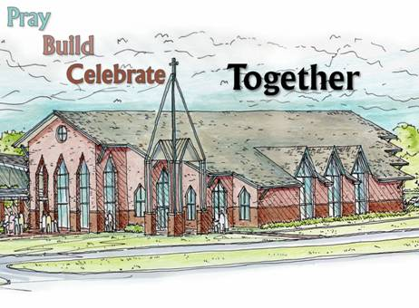
St. Sylvester Catholic Church & Multi-Purpose Building
General Contractor: Greenhut Construction Company, Inc.

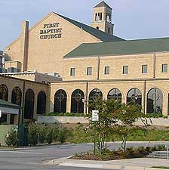
First Baptist Church, Pensacola, FL
Electrical Renovations
General Contractor: G H Construction Services, Inc.

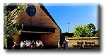
Gulf Breeze United Methodist Church
General Contractor: Greenhut Construction Co., Inc

Good News United Methodist Church
General Contractor: Greenhut Construction Company, Inc.

St. Ann’s Catholic Church – Gym Lighting Replacement
General Contractor: Greenhut Construction Co., Inc.

